FINANCIAL ACCOUNTING(FA)
CORE-(CC-I)
QUESTIONS BANKS
Unit-I
1. The following questions are : 7 ½
a) Define Accounting. Discuss the advantages and disadvantages of accounting.
b) What is a Realization Account ? How it differ from Revaluation Account ?
c) Difference between Journal and Ledger.
2. Difference between Accrual Basis of Accounting and Cash Basis of Accounting.
12 ½
Unit-II
1. The following question are : 7 ½
a) Define Income. What are the objectives of Net Income reporting?
b) In computing costs, the owner of the filling station ‘A’ assumed that he was always pumping off the bottom of his tank. On 31st March both had the same inventory of 6,000 litres which cost 1.10 per litre. In April, each owner bought an additional 6,000 litres at 1.15 per litre. Sales during April for each station amounted to 8,000 litres at 1.40 per litre. Determine for each station the net profit for the period, and the value of closing stock.
c) Concepts of AS, IFRS, XBRL.
2. Measurement of Business Income requires matching cost with the Revenue. Explain. 12 ½

Unit-III
1. The following question are : 7 ½
a) What is deferred Revenue Expenditure ? Explain with suitable Example.
b) Classification of Assets and Liabilities.
2. Following are the Balances of Shri Rabi as on 30th June, 2019:
Debit Balances: Rs. Debit Balances: Rs.
Cash in Hand 540 Patents 7,500
Cash at Bank 2,630 Salaries 15,000
Purchases 40,675 General Expenses 3,000
Returns Inward 680 Insurance 600
Wages 8,480 Drawings 5,245
Fuel and Power 4,730 Sundry Debtors 14,500
Carriage on Sales 3,200 Credit Balances :
Carriage on Purchases 2,040 Sales 98,780
Stock (1st July, 2018) 5,760 Returns Outwards 500
Buildings 22,000 Capital 62,000
Freehold Land 10,000 Sundry Creditors 6,300
Machinery 20,000 Rent 9,000
Investments 10,000

Taking into account the following adjustments prepare the Trading and Profit and Loss Account and Balance Sheet as on 30th June, 2019:
(a) Stock on hand on 30th June, 2019 is Rs.6,800. (b) Machinery is to be depreciated at the rate of 10% and Patents at the rate of 20%. (c) Salaries for the month of June, 2019 amounting to Rs.1, 500 were unpaid. (d) Insurance includes a premium of Rs.170 on a Policy expiring on 31st December 2019. (e) Bad Debts are Rs.725. (f) Rent Received in Advance Rs.1, 000. (g) Interest on Investment of Rs.2,000 is accrued. 12 ½
3. Write notes on:
a) Admission of partner
b) Death of partner
c) Dissolution of the Partnership Firm 12 ½
Unit-IV
The following question are : 12 ½
1. On 1st January, 2020 Manas Purchased a Machine from Ashoka Ltd. on hire purchase system. The Cash Price of Machine was Rs.1, 30,000 and the payment was to be made Rs.40, 000 down and remainder in three equal Installments of Rs.30, 000 each together with interest at 15%p.a. Manas writes off depreciation @10% on written down value method. Manas could not pay the installment due on 31st December, 2021 and Ashoka Ltd. arranged immediately to take back the machine which cost Rs.60, 000 allowing Rs.41, 500 provided that Manas paid all the interest due to that date on the full amount owing.
Show Machine Account and Ashoka Ltd. Account in the books of Manas.

2. On 1st January, 2020, Ram oil Company purchased an oil machine on the instalment system. The cash price of the machine was Rs.11,175 and payment was to be made as follows :
Rs.3,000 was to be paid on the signing of the agreement and the balance in three instalments of Rs.3,000 each at the end of each year , 5% interest is charged by the Delhi Manufacturing Company per annum. Ram oil Company has decided to write off 10 per cent annually on the diminishing balance of the cash price.
Give Journal entries and Ledger Accounts in the books of purchaser and vendor both. Calculations are to be made to the nearest Rs.
3. Write down the Accounting , Treatment passed under ‘Stock and Debtor’ system to maintain the Branch Account.
4. Discuss the Hire Purchase and Instalment System.

CORPORATE ACCOUNTING(CA)
CORE-(CC-V)
QUESTIONS BANKS
Unit-I
1. The following question are : 7 ½
a) Define Prospectus. What are the main contents of the prospectus ?
b) Difference Between Vesting Period and Exercise Period.
2. Distinguish between (i) a debenture and a share, and (ii) debenture and debenture stock.
Unit-II
1. The following question are: 7 ½
a) Discuss the Redemption of Debenture and its Important provisions. 2. Balance Sheet taken from the books of a company is as follows : 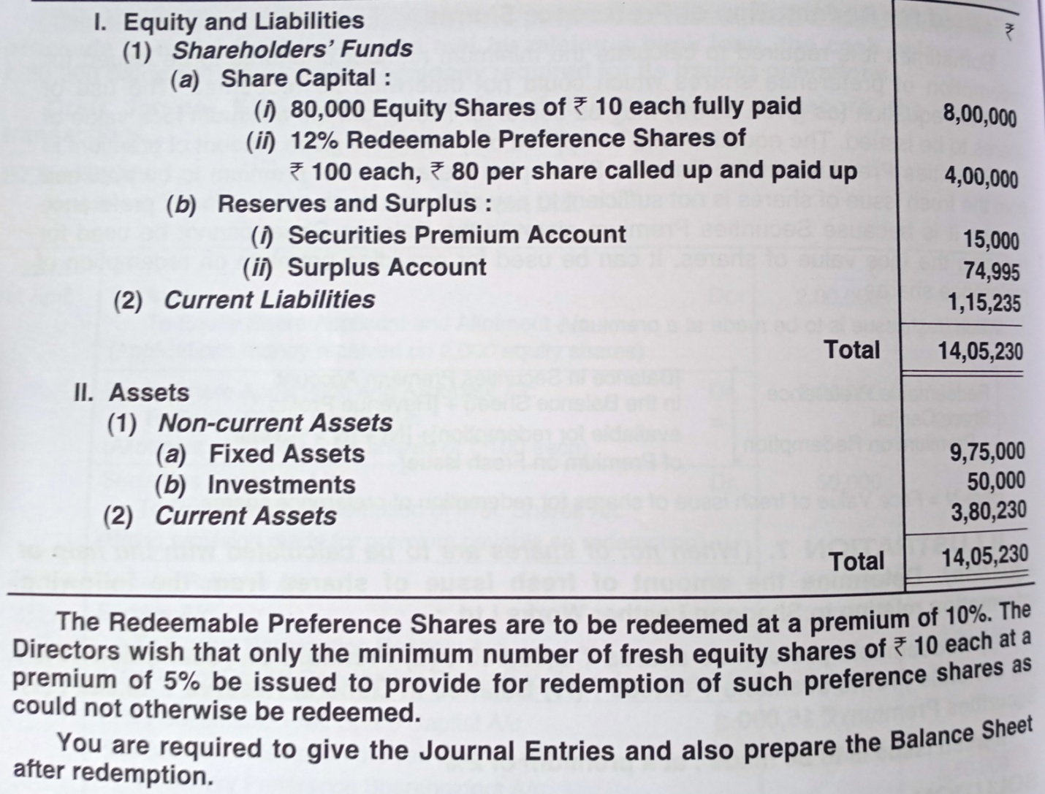 12 ½
3. Write notes on:
a) Buyback of Shares.
b) Right Issue.
c) Bonus Shares. 12 ½

Unit-III
1. The following question are : 7 ½
a) Describe any one method of valuing shares with its suitability.
b) Explain Schedule III of the Indian Companies Act.
c) The net profit of a business after providing for taxation for the past five years are : Rs.40,000, 42,500, 46,000, 52,500 and 59,000. The capital employed in the business is Rs.4,00,000. The normal rate of return of this type of business is 10%. The company will be able to maintain its super profit for the next five years.
Calculate Goodwill on the basis of :
(i) Five years’ purchase of super profits
(ii) Annuity method, taking the present value of annuity of Rs. 1 for five years at 10% as 3.78.
(iii) Capitalisation of super profit method.
2. Prepare in a summerised form and contents of the Balance Sheet of a company as per Companies Act, 2013 with imaginary figures.
12 ½
3. The following is the Trial Balance of Hari Ltd. as on 31st March, 2020.
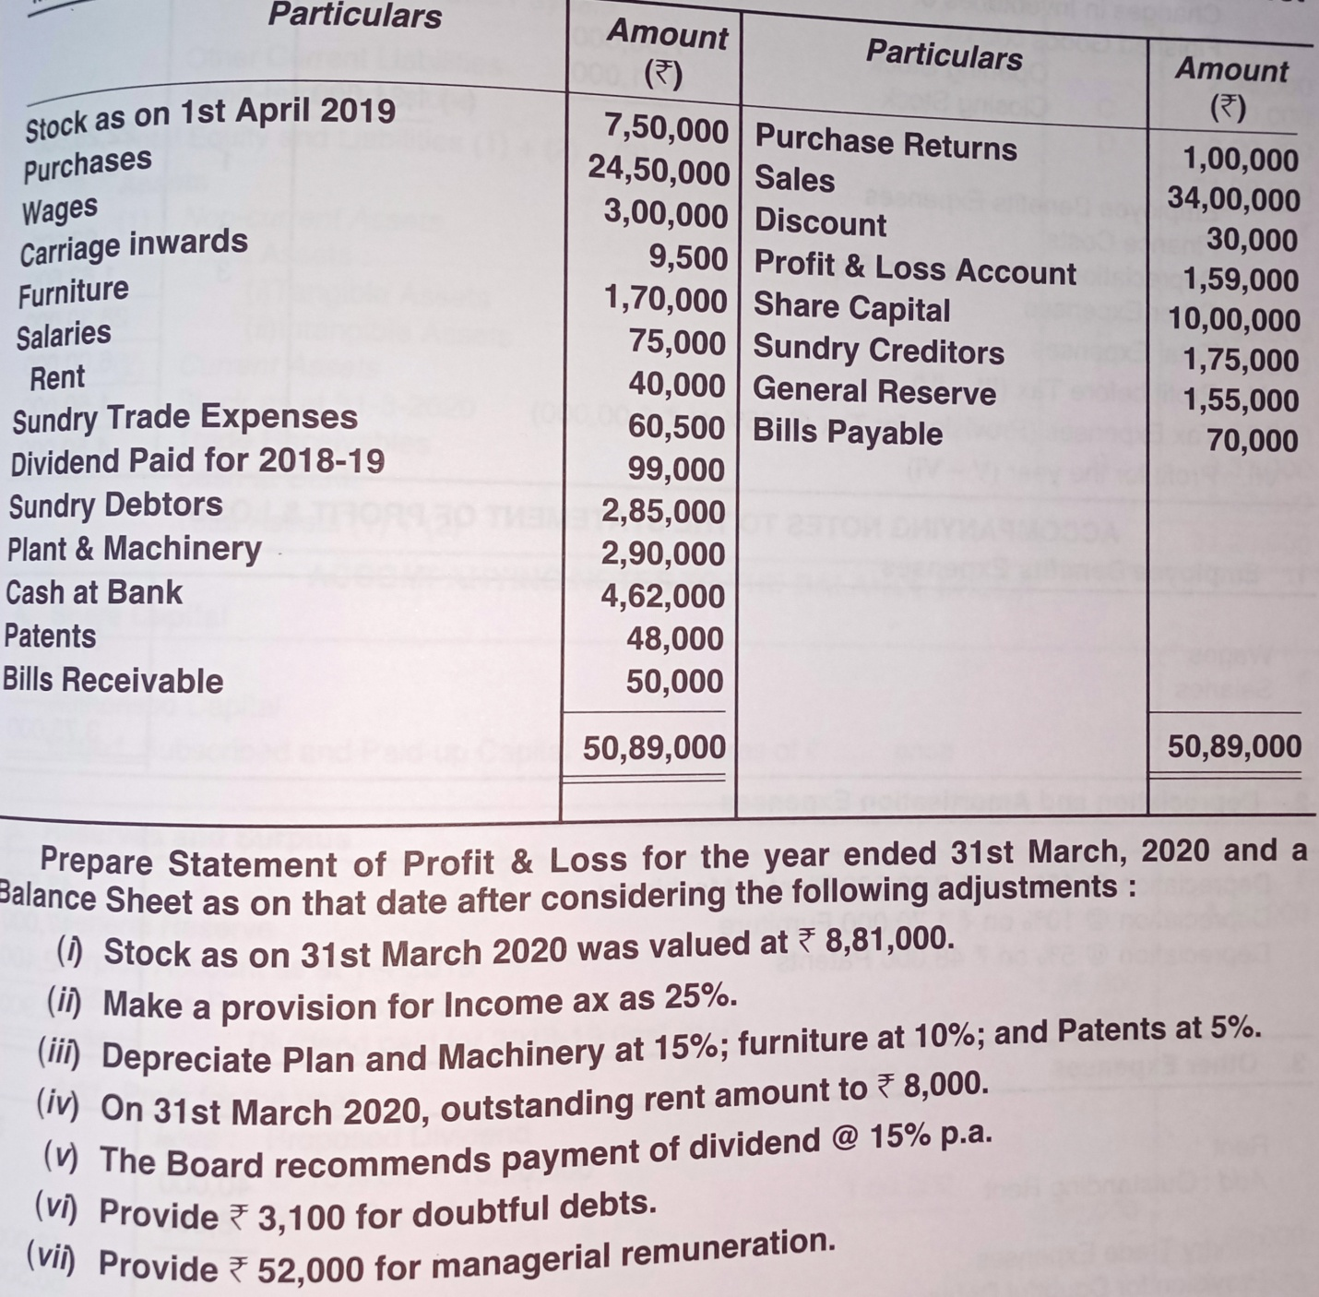
12 ½

Unit-IV
1. The following question are : 7 ½
a) Contributories of list “B”.
2. Bekar Limited went into voluntary liquidation. The details regarding liquidation are as follows :
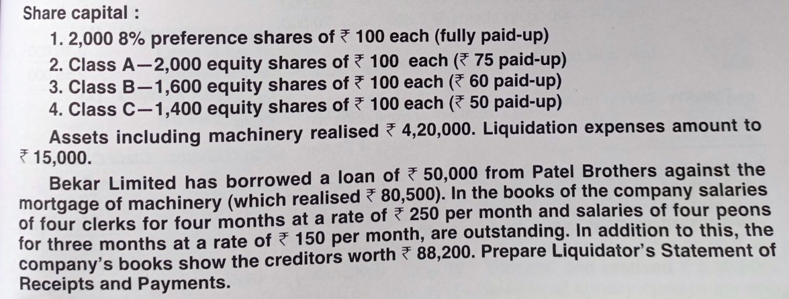 12 ½
3. Distinguish between Statement of Affairs and Balance Sheet.
12 ½

COST ACCOUNTING(CA) CORE-(CC-III)
QUESTIONS BANKS
Unit-I
1. The following questions are : 7 ½
a) Explain the concept of cost. Also distinguish between direct cost and indirect cost.
B. 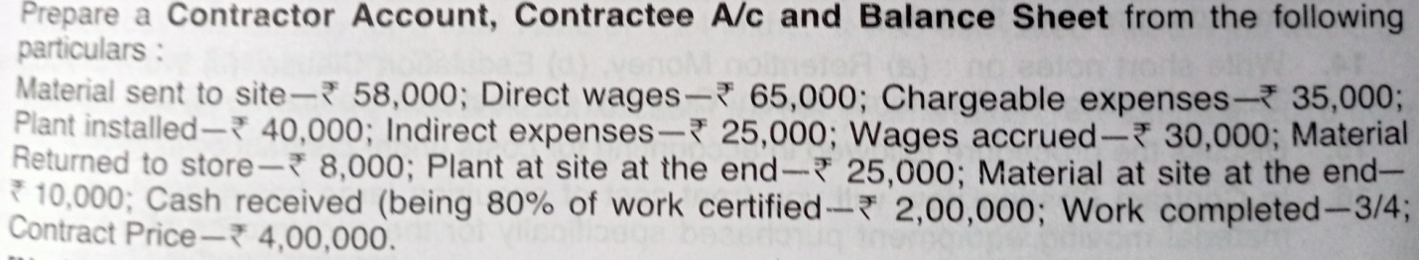
c) Short Notes:
i) Give a simple Format of Cost sheet (without stock treatment)
ii) Discuss the elements of cost.
2. What is cost accounting. Its importance and limitations of cost accounting.
12 ½
Unit-II
1. The following questions are : 7 ½
a) Define ABC. What are the important characteristics ABC ?
2. 80 kgs of material A, at a standard price of 2 per kg and 40 kgs of material B, at a standard price of 5 per kg, were to be used to manufacture 100 kgs of chemical. During a month, 70 kgs of material A priced at 2.10 per kg and 50 kgs of material

B priced at 4.50 per kg , were actually used and the output of the chemical was 102 kgs.
Find out material veriances. 12 ½

3. The record of issues and receipts for a month is given below. You are required to prepare the Store Ledger Account using “FIFO” method.
August 1, 2019 opening balance 500 tons @20 per ton
August 2 Issued 100 tons
August 3 Issued 50 tons
August 4 Issued 200 tons
August 7 Purchased 200 tons @ 19.50 per ton
August 16 Refund From Dept,20 tons @ 19 per ton
August 17 Issued 200 tons
August 21 Purchased 150 tons @ 20.50 per ton
August 25 Issued 250 tons
August 27 Purchased 300 tons @ 20 per ton
August 30 Issued 200 tons
August 31 Refund From Dept. 15 tons @ 20.50 per ton.
Further the stock verification report reveal a loss of 5 tons on 5th August and another shortage of 4 tons on 28th August. 12 ½

Unit-III
1. The following questions are : 7 ½
a) What is Under absorption and over absorption of overheads ?
b) Re-apportionment of Service Department Cost to Production Departments.
2. Explain the Direct Labour Cost method its Suitability, Advantages and Disadvantages. 12 ½
3. Discuss the Under absorption and Over absorption of overheads 12 ½
4. Write Notes On:
Methods of wage payment and the Incentive Schemes and discuss Differential Piece wage plan-
(i) Halsey’s
(ii) Rowan’s
(iii) Taylor’s 12 ½

Unit-IV
1. The following questions are : 7 ½
a) What is Process loss and its Wastages.
b) The Meaning and Characteristics of process costing :
2. The following details relate to an intermediary process in a factory :
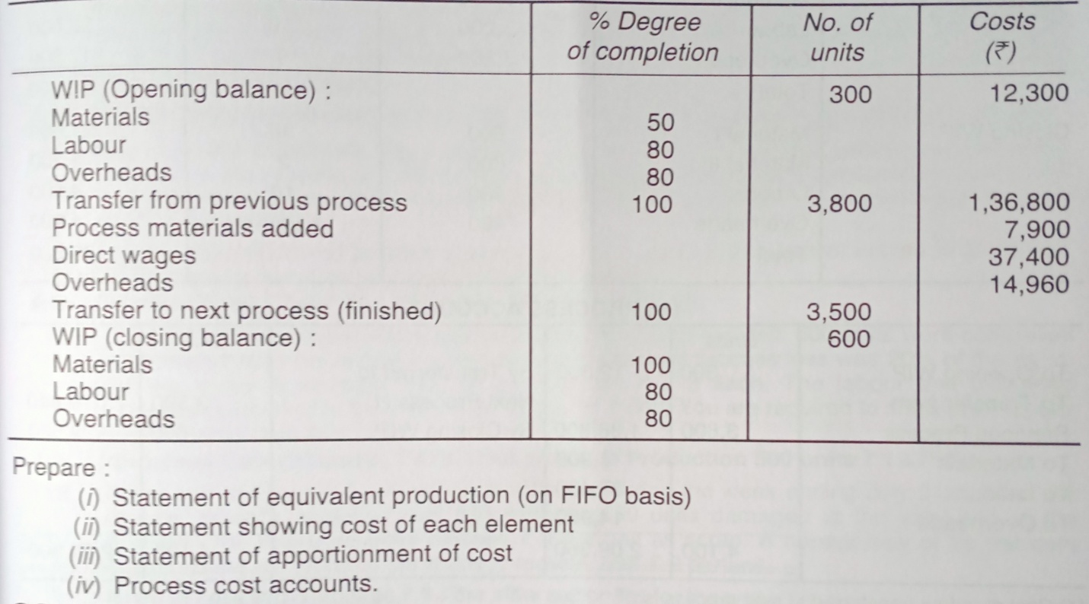
12 ½

